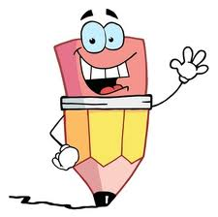
Readers Respond with Evidence
Response | Evidence
I noticed that…  This makes me think…  I can infer the author means…  I used to think… but now I think…  The lesson we can learn here is…  I was confused when…  I wonder…  I predict that…  This is important… | because…  For instance…  For example…  The author stated…  According to the text…  On page __, it said…  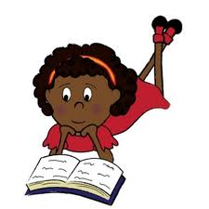
Readers Respond with Evidence
Response | Evidence
I noticed that…  This makes me think…  I can infer the author means…  I used to think… but now I think…  The lesson we can learn here is…  I was confused when…  I wonder…  I predict that…  This is important… | because…  For instance…  For example…  The author stated…  According to the text…  On page __, it said…

Readers Respond with Evidence
Response | Evidence
I noticed that…  This makes me think…  I can infer the author means…  I used to think… but now I think…  The lesson we can learn here is…  I was confused when…  I wonder…  I predict that…  This is important… | because…  For instance…  For example…  The author stated…  According to the text…  On page __, it said…

